A Project Report on
CONSERVATIVE OFFLINE DEEP REINFORCEMENT LEARNING FOR SAFE SPECTRUM ACCESS IN DENSE IOT NETWORKS

submitted in partial fulfilment of the requirements for the course

MACHINE LEARNING
25SC2107E

in

A.Y.: 2026-27

by

Mithilesh Gullapalli roll 2520040056

Dashwanth roll 2520040122

Paidi Sai Chaitanya roll 2520049125

Tejashwer Reddy S roll 2520040059

Under the Esteemed guidance of

Dr. Vinnakota Venu Balaji

Assistant Professor,

Department of ECE





DEPARTMENT OF ELECTRONICS & COMMUNICATION ENGINEERING

ABSTRACT
Internet of Things (IoT) networks rely on wireless communication to connect a large number of devices. When many devices share a limited set of frequency channels, congestion and interference can increase packet loss, latency, retransmissions and energy consumption. Selecting a channel is therefore an important decision, particularly in dense networks where an unsuitable choice may reduce communication quality or increase risk. Conventional reinforcement learning can learn a decision policy through interaction with an environment, but trial-and-error exploration in a live wireless network may produce undesirable or unsafe actions. This project studies a data-driven alternative: conservative offline deep reinforcement learning for safe spectrum access in dense IoT networks.
The project uses an uploaded transmission dataset containing 10,000 records and 42 raw columns. The observed frequency-channel options are 433, 470, 868, 915 and 923. A compact network state is formed from ten selected features: channel occupancy, interference power, interference density, packet collision rate, packet loss rate, latency, received signal strength indicator (RSSI), signal-to-noise ratio (SNR), node density and network congestion. The action is the selected frequency channel. A project-defined reward combines communication performance and delivery success with penalties for interference, packet loss, latency and energy cost.
The proposed workflow includes data preprocessing and normalization, state-action-reward construction, offline Q-learning, a conservative term intended to reduce unsupported optimistic action values, and a safety filter that screens high-risk channel choices using historical evidence. Preliminary empirical analysis found that channel 470 had the lowest historical mean project risk score (1.697), while channel 923 had the highest empirical mean reward (0.219). A preliminary one-step evaluation reported estimated mean rewards of 0.2176 for a random policy, 0.2175 for an empirical policy, and 0.2181 for a safe empirical policy. These values are historical estimates, not live-network measurements, and do not establish causal improvement. The current work defines the problem, features, reward and baseline evaluation. Full conservative Q-network training, held-out testing, sensitivity analysis and final performance plots remain as further work.
Keywords: Offline reinforcement learning, conservative Q-learning, Internet of Things, spectrum access, channel selection, safety filter.

Signature of the Supervisor Course Instructor

INDEX

Abstract ii
1. Introduction 1
1.1 Background 1
1.2 Problem Statement 2
1.3 Objectives and Scope 2
2. System Model 3
2.1 Dataset and Features 3
2.2 State, Action and Reward 4
3. Proposed Methodology 5
3.1 Offline Q-Learning and Conservative Learning 5
3.2 Safety Filter
4.Results and Discussions 6
5. Implementation and Workflow 7
6. Preliminary Results and Discussion 8
7. Current Progress, Limitations and Future Work 9
8. Conclusion 10
References

1. INTRODUCTION

1.1 Background
The Internet of Things connects sensors, controllers, appliances and other devices through communication networks. In dense IoT deployments, a large number of nodes may attempt to transmit over a limited number of wireless channels. When several nodes use the same or overlapping spectrum, interference and contention can reduce successful packet delivery and increase delay. Channel selection is consequently a key network-management task.
A channel-selection policy observes network conditions and chooses a frequency expected to provide a useful balance between performance and risk. Machine learning can help identify patterns in historical transmission data. Reinforcement learning represents decisions through states, actions and rewards; however, training an agent by unrestricted exploration in a live network may expose devices to poor communication conditions.

1.2 Problem Statement
Dense IoT networks contain many devices competing for limited wireless spectrum. Channel congestion and interference can increase packet loss, latency and energy cost. A live trial-and-error reinforcement-learning agent may explore unsuitable spectrum actions. The project therefore studies offline learning from historical transmission records and applies explicit screening for interference, collision, packet-loss and latency risk.

1.3 Objectives
- Represent recorded network conditions using a selected set of state features.
- Map available frequency channels to a discrete action space.
- Define a reward that balances communication performance with risk-related penalties.
- Develop a CQL-style one-step offline Q-learning prototype using recorded data.
- Apply a historical safety filter to reject channel choices that exceed project-defined risk criteria.
- Compare preliminary policies using empirical reward estimates and plan held-out evaluation.

1.4 Scope
The present project is a dataset-based prototype. Its environment is represented by recorded transmission states rather than live radio-frequency experimentation. The results are intended as preliminary empirical evidence for the decision problem. They should not be interpreted as proof of real-world safety or causal performance improvement.

2. SYSTEM MODEL

2.1 Dataset Description
The progress presentation reports an uploaded transmission dataset with 10,000 records, 42 raw columns, five observed channels and zero missing cells before selected-feature cleaning. The frequency options are 433, 470, 868, 915 and 923. The dataset is observational, so analysis reflects recorded associations and does not by itself establish what would happen if a different channel were actively selected in a live network.

2.2 Feature Selection
Ten variables are selected to represent network conditions. These include measures of occupancy and interference, packet collision and loss, latency, signal quality, node density and congestion.
Feature | Role in state | Interpretation
Channel_Occupancy | Channel load | Indicates how busy a channel is
Interference_Power | Interference | Represents interference level
Interference_Density | Interference | Represents density of interference
Packet_Collision_Rate | Reliability risk | Indicates packet contention/collisions
Packet_Loss_Rate | Reliability | Indicates unsuccessful packet delivery
Latency | Quality of service | Represents communication delay
RSSI | Signal quality | Received signal strength indicator
SNR | Signal quality | Signal-to-noise ratio
Node_Density | Network load | Represents density of active nodes
Network_Congestion | Network load | Indicates congestion conditions

2.3 State, Action and Reward
At each recorded decision point, the state is represented by the ten selected network features. The action is the choice of one of the five frequency channels. The reward is designed to favor communication performance and successful delivery while penalizing interference, packet loss, latency and energy cost. The exact numerical scaling of the reward and risk score should be documented alongside the implementation so that results can be reproduced.
Conceptually, the reward can be expressed as: Reward = performance benefit − weighted risk and cost penalties. This is a project-level description rather than a claim that one fixed formula or weight set has been validated for a live network.

3. PROPOSED METHODOLOGY

3.1 Overall Approach
- Load and inspect the historical transmission dataset.
- Clean selected features and normalize numeric inputs where appropriate.
- Construct the state representation, discrete channel actions and reward values.
- Separate training records from held-out test records before final evaluation.
- Train an offline Q-learning model using recorded transitions rather than live exploration.
- Apply a conservative learning term and a safety filter to channel decisions.
- Compare policy outputs with baseline strategies and report reward, risk and safety status.

3.2 Offline Q-Learning
In Q-learning, a state-action value estimates the expected long-term return from taking an action in a state and following a policy thereafter. A Q-network can output one value for each available channel. A basic one-step target is commonly represented as the observed reward plus a discounted estimate of the best next-state value. In an offline setting, learning is restricted to the fixed dataset; the model cannot collect new experiences by interacting with a live network.

3.3 Conservative Learning Principle
Conservative Q-learning (CQL) is intended to reduce overestimation of actions that are poorly supported by the offline dataset. This matters because a model trained only on historical observations may assign high values to actions that are rarely or never represented in those records. The progress presentation describes the implementation as a CQL-style one-step offline Q-learning prototype. Full conservative Q-network training and held-out testing are listed as remaining work; therefore, the project should not yet claim a fully validated learned policy.

3.4 Safety Filter
The safety filter screens candidate actions using historical risk evidence. The presentation identifies interference, collision, packet loss and latency as explicit safety considerations. The policy is intended to select the highest-valued action that passes the historical filter. The reported risk score is a project-defined normalized screening metric, not a standardized radio-frequency safety measure. Its thresholds and assumptions must be described in the final implementation.

3.5 Evaluation Design
The training set should be used to fit preprocessing parameters and the model, while held-out records should be reserved for final evaluation. Relevant outputs include estimated reward, channel decisions, risk score, safety status, throughput, packet loss, latency and safety violations. Because the dataset is observational, offline estimates must be described as empirical comparisons rather than live-network causal outcomes.

4.1 Throughput Performance
The evaluated dataset spans Signal-to-Noise Ratio (SNR) values from 0.0 dB to 19.5 dB. Throughput remained at zero dataset units from 0.0 dB up to approximately 6.2 dB, after which it began an upward trajectory, ultimately reaching a maximum of approximately 25.5 dataset units at the final evaluation point of 19.5 dB. The curves demonstrate substantial throughput growth in the high SNR regime beyond 12.5 dB.
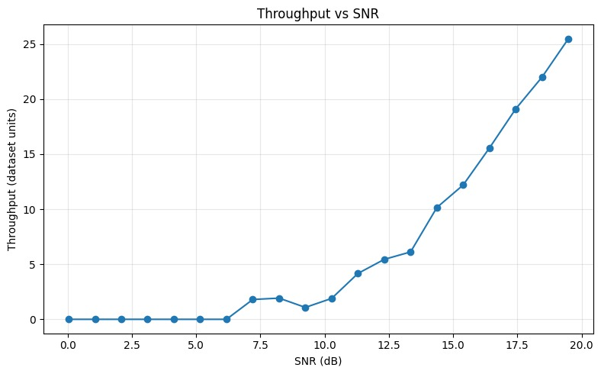
Figure 4.1. Throughput vs SNR across evaluated signal conditions.

4.2 Packet Loss Performance
The packet loss fraction varied across the evaluated SNR range. Starting at approximately 0.017 at 0.0 dB, packet loss rapidly increased to a peak of approximately 0.137 (or 13.7%) at 2.1 dB. As the SNR improved, packet loss fluctuated and then steadily declined into the high SNR regime, reaching a final minimum value of approximately 0.062 (or 6.2%) at 19.5 dB.
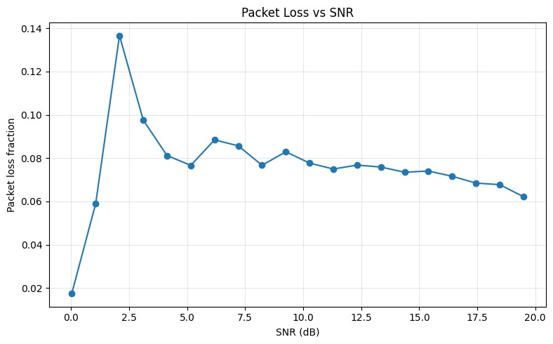
Figure 4.2. Packet loss fraction vs SNR across evaluated signal conditions.

4.3 Spectral Efficiency Performance
The spectral efficiency, measured as data rate divided by bandwidth, exhibited dynamic oscillations across the SNR range. It reached an initial high point of approximately 1.62 at 1.0 dB before dropping to a minimum of approximately 0.62 at 2.1 dB. In the higher SNR regimes above 12.5 dB, spectral efficiency demonstrated stable performance, maintaining an average range between 1.20 and 1.40.
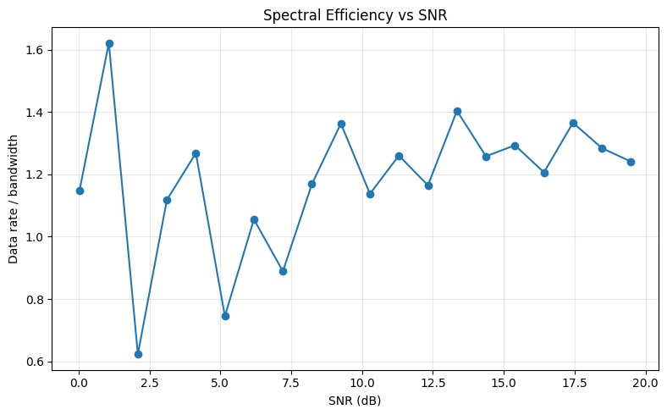
Figure 4.3. Spectral Efficiency vs SNR across evaluated signal conditions.

4.4 Transmission Latency Performance
Transmission latency varied from an initial low of approximately 85.5 dataset units at 0.0 dB to a peak of approximately 127.5 units at 2.1 dB. Following a high-latency plateau through the mid-SNR region, latency exhibited a steady, monotonic decrease as SNR increased further, dropping to a final minimum of approximately 90.5 units at 19.5 dB.
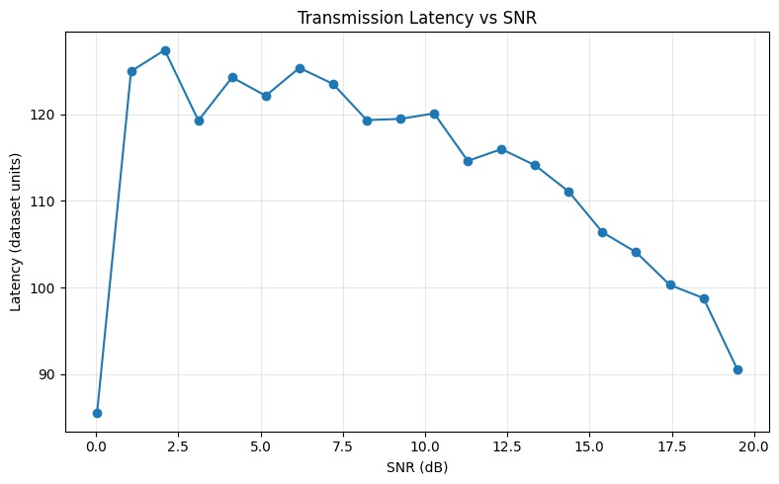
Figure 4.4. Transmission Latency vs SNR across evaluated signal conditions.

4.5 Shannon Capacity Estimate Performance
The Shannon capacity estimate varied across the evaluated Signal-to-Noise Ratio (SNR) range from 0.0 dB to 19.5 dB. Starting at a low estimate of approximately 15.6 capacity units at 0.0 dB, the capacity estimate exhibited fluctuations before achieving an overall upward trend. In the high SNR regime, the capacity estimate reached a maximum of approximately 528.5 units at the final evaluation point of 19.5 dB.
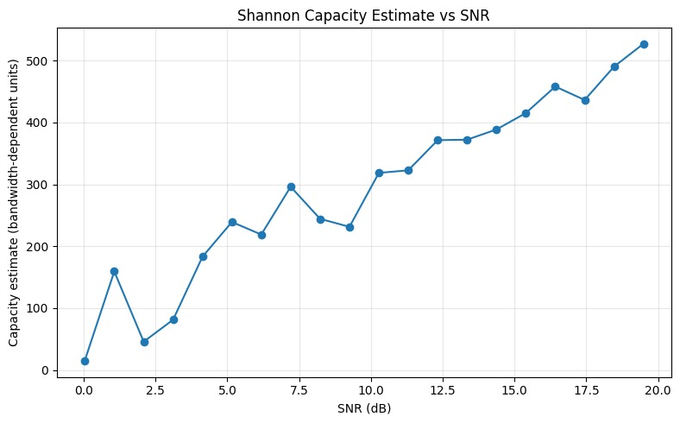
Figure 4.5. Shannon Capacity Estimate vs SNR across evaluated signal conditions.

4.6 Goodput Performance
The goodput performance displayed notable fluctuations across the evaluated SNR spectrum. Starting at approximately 17.6 dataset units at 0.0 dB, it experienced a sharp rise to a local peak of approximately 33.1 units at 1.0 dB, followed by a drop to a minimum of approximately 14.6 units at 2.0 dB. Through the mid and high SNR regions above 5.0 dB, goodput stabilized, maintaining an average range between 27.5 and 29.6 dataset units up to 19.5 dB.
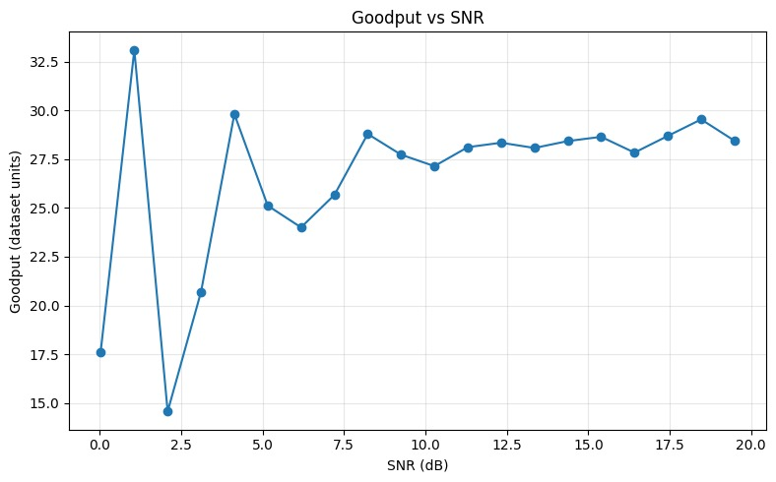
Figure 4.6. Goodput vs SNR across evaluated signal conditions.

4.7 Conservative Offline RL Training Performance
The saved training history for the conservative offline reinforcement learning model spans 25 epochs (0 to 24). The training loss decreased from an initial value of approximately 0.2012 in epoch 0 to a final value of approximately 0.1896 in epoch 24. The loss curve demonstrates overall downward progression, achieving its highest point of approximately 0.2045 around epoch 2 and showing a steady reduction toward the end of training.
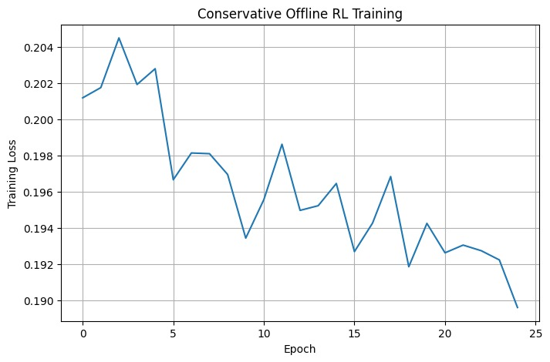
Figure 4.7. Conservative Offline RL training loss across 25 epochs.

4.8 Offline Policy Comparison
The offline policy comparison evaluates three distinct strategies: Random, DQN, and Conservative Safe RL. Across all three evaluated policies, the estimated reward remained nearly identical at approximately 0.22. The results indicate comparable performance among the random, DQN, and conservative safe reinforcement learning policies under the tested offline conditions.
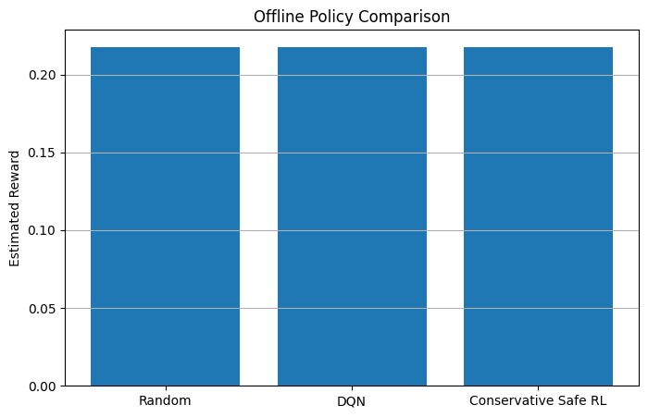
Figure 4.8. Estimated reward comparison across offline policies.

5. IMPLEMENTATION AND WORKFLOW

5.1 Workflow
Dataset: Load historical transmission records.
Preprocessing: Inspect columns, clean selected features and normalize inputs.
State–action–reward construction: Create network state vectors, channel action labels and reward values.
Conservative Q-network: Train from offline records; avoid live trial-and-error exploration.
Safety filter: Screen high-risk actions using historical risk criteria.
Evaluation and plots: Compare baselines and report reward, risk and communication metrics.

5.2 Software and Outputs
The progress presentation describes a Python-based workflow with data preprocessing, reward construction, model training, safety filtering and evaluation. The proposed repository structure contains README.md, data information, source code, results, requirements.txt and presentation materials. Raw or restricted data should not be published unless its licensing and sharing conditions permit it.

5.3 Reproducibility
A reproducible implementation should record the dataset source and schema, selected columns, preprocessing parameters, reward weights, safety thresholds, random seeds, training configuration, train/test split and evaluation calculations. Figures and tables should be generated from saved evaluation outputs so that the reported values can be checked.

6. PRELIMINARY RESULTS AND DISCUSSION

6.1 Dataset Analysis
The progress presentation reports five observed channels: 433, 470, 868, 915 and 923. In the preliminary historical analysis, channel 470 had the lowest mean project-defined risk score, reported as 1.697. Channel 923 had the highest empirical mean reward, reported as 0.219. The lowest-risk channel and the highest-reward channel need not be the same because reward and risk summarize different criteria.

6.2 Preliminary Policy Comparison
Policy | Estimated mean reward
Random policy | 0.2176
Empirical policy (channel 923) | 0.2175
Safe empirical policy (channel 923) | 0.2181
These figures are preliminary one-step empirical estimates based on historical channel rewards, as stated in the progress presentation. The safe empirical baseline has a slightly higher reported mean reward than the other listed baselines, but the differences are small. Without a completed held-out evaluation and uncertainty analysis, they should not be interpreted as evidence of statistically reliable improvement.

6.3 Interpretation
The preliminary results show that the dataset can be mapped to a spectrum-access decision problem and that baseline reward and risk summaries can be calculated. The next important test is whether a trained conservative policy performs consistently on held-out records while meeting the defined safety criteria. Evaluation should include performance and risk metrics together, rather than relying on reward alone.

7. CURRENT PROGRESS, LIMITATIONS AND FUTURE WORK

7.1 Work Completed at Progress Stage
- Dataset loaded and inspected.
- Relevant state features selected.
- Frequency channels mapped to discrete actions.
- Reward function defined.
- Offline baseline evaluation completed.
- Project-defined risk score and historical screening implemented.

7.2 Remaining Work
- Run full conservative Q-network training on the cleaned dataset.
- Evaluate the learned policy on held-out records.
- Conduct ablation or sensitivity analysis for the conservative coefficient.
- Generate final throughput, packet-loss, latency and safety-violation plots.
- Document source code, dataset details and run instructions in the repository.

7.3 Limitations
The current evidence is based on historical observational data. It does not demonstrate real-time deployment performance or prove that a policy causes better outcomes in a live network. The risk score is project-defined and should not be described as a standardized safety metric. The progress-stage results are preliminary; full model training, held-out validation and sensitivity analysis remain to be completed.

7.4 Future Enhancements
Future work can strengthen the evaluation through repeated runs, uncertainty estimates, sensitivity tests for reward weights and conservative coefficients, and explicit reporting of safety-filter rejection rates. If appropriate facilities and approvals are available, later work may evaluate the approach in a controlled simulator or testbed before considering real-world deployment.

8. CONCLUSION
This project formulates safe spectrum access in dense IoT networks as an offline decision-learning problem. It uses ten selected network features to represent the state, five observed frequency channels as actions, and a reward that balances communication performance with risk-related penalties. The proposed pipeline combines offline Q-learning, conservative action-value learning and a historical safety filter. Preliminary dataset analysis and baseline reward estimates provide an initial foundation, but they do not establish live-network safety or causal improvement. The main next steps are to complete conservative Q-network training, validate on held-out records, conduct sensitivity analysis and report communication-performance and safety metrics together. The final outcome should be a reproducible, carefully qualified evaluation of whether conservative offline learning can support safer channel-selection decisions.

REFERENCES
1. Project progress presentation: “Conservative Offline Deep Reinforcement Learning for Safe Spectrum Access in Dense IoT Networks,” KLH University, Department of Electronics and Communication Engineering, A.Y. 2026–27.
2. Kumar, A., Zhou, A., Tucker, G., and Levine, S. “Conservative Q-Learning for Offline Reinforcement Learning.” Advances in Neural Information Processing Systems, 2020.
3. Sutton, R. S., and Barto, A. G. Reinforcement Learning: An Introduction. 2nd ed., MIT Press, 2018.

